Supply
Date: December 10, 2025

I. PURPOSE.
This meeting establishes a recurring battle rhythm of the DoD Supply Working Group to deliver processes and quality data standards that exemplify Accuracy, Conformity, Consistency, and Integrity to our Logistics Supply Community.

II. ATTENDEES.
Component | Primary | Alternate
ODASW(LOG) | ☒Jameka Harrell
DEDSO | ☒Dr. Gail Fuller / ☒Steve Nace / ☒Tonja Carter / ☒Jess Gratkowski / ☒Alexa Ferrari
DAAS | ☐Pablo Gomez | ☐Gary Woodall
Army | ☐Oliver Pryor | ☒Tiffanie Dew
Marine Corps | ☐Kevin Austin
Navy | ☐Shannon Winters | ☒Gerald O’Sullivan
Air Force | ☒William “Wes” Wenzel | ☐MSgt Ryan
USSOCOM | ☐Luke Boutot | ☐CW5 Sanders
USTRANSCOM | ☐Dan Eisenberg | ☐James Decarli
DLA | ☒Brian Anderson | ☒Eric Flanagan
DSCA
GSA | ☐Shanna Smith | ☐George Oakes
FAA | ☐Dr. Sarah Owens | ☐Hannah McClellan

III. Action Items.
Date Opened | Action | Assigned To | Date Due | Date Closed | Status
12/10/2025 | DoD Components provide feedback on the DLMS 867I use cases within your component. | - Army  - Marine Corps  - Navy  - Air Force  - DLA | 1/7/2026 |  | Open
12/10/2025 | DoD Components provide DEDSO with some APSR POCs to participate in a meeting to discuss new GFP related Product ID changes for the DLMS 947I. | - Army  - Marine Corps  - Navy  - Air Force  - DLA | 1/7/2026 |  | Open
9/17/2025 | Discuss new versus newly reworked/repaired internally for further discussion with the working group. | - All trading partners | 10/01/2025 |  | Closed
9/17/2025 | Review all past MOV questions/responses for potential future efficiencies. | - DEDSO (leading)  - Trading Partners (supporting) | 10/01/2025 |  | Closed

IV. PDC/ADC Pipeline.
PDC/ADC # | Meeting Added | Title | Status
PDC 1478 | 8/21/2024 | Clarified Price Adjustments via DLMS Status Update | Worked with DLA/ Finance to finalize the long-term
PDC 1492 | 1/8/2025 | Mandatory Use of Shipment Status and Returns | On Hold
PDC 1497 | 3/5/2025 | Notification of Hazardous Waste Delivery Order and Shipping Status | Approved 10/10/2025
PDC 1491 | 3/26/2025 | Government Furnished Property (GFP) Embed | Approved 12/5/2025
PDC 1500 | 3/26/2025 | PDC 1500 - Deconflicting Coding Updates for Acquisition and Valuation Transactions | Approved 12/8/2025
PDC 1501 | 4/16/2025 | Key Supporting Document Inclusions for Government Furnished Property Audit Compliance (Supply) | Approved 12/2/2025
PDC 1043H | 7/9/2025 | Revised Procedural Requirements for Hazardous Property Disposal Release Orders (Supply/Finance) | Pending DLA Adjudication Comment Review
PDC 1510 | 7/23/2025 | Add OM&S Reportable Method to 832N Catalog Data Support (Supply) | Signed 10/9/2025, will forward to the field 11/19/2025
PDC 1513 | 10/1/2025 | Interim Requirement Revisions to the DLMS 527R (Materiel Receipt) and DLMS 846R (Location Reconciliation Request) Transaction Sets | Sent for formal coordination on 12/8/2025
PDC 1514 | 10/21/2025 | Air Force Implementation of the 940R (Materiel Release) Version 4050 | In development
PDC 1515* | 12/10/2025 | Product Identifier Inventory Adjustments for Government Furnished Property (Supply) | In development
PDC 1516* | 12/10/2025 | Proposed Defense Logistics Management Standards (DLMS) Change (PDC) 1516 Standardizing Receipt Cancellations (Supply) | In development
ADC 267* (Withdrawal) | 12/10/2025 | Withdrawal of Approved Defense Logistics Management Standards Change 267, Interim Change for DLMS 527R Receipt to Support Intra-Army direct Support/Reparable Exchange Decapitalization Transaction (Supply/MILSTRAP) (Staffed as PDC 290) | On internal DEDSO hold
PDC 1517* | 12/10/2025 | Update to DLMS 947I, Inventory Adjustment to support Government Furnished Property (Supply) | In development
PDC 1455* | 12/10/2025 | Proposed Defense Logistics Management Standards Change 1455, Removal of Passive Radio Frequency Identification References in Defense Logistics Management Standards Publications and Implementation Conventions | In development
PDC 1520* | 12/10/2025 | Additional Property/Service ID Pair within the 945A Materiel Release Advice (Supply) New (F-35) Meet with Data team to discuss new qualifiers | In development
ADC 1484A* | 12/10/2025 | Proposed Defense Logistics Management Standards (DLMS) Change (PDC) 1484A, Update the Defense Logistics Management Standard 888N, Cataloging New Item Implementation Convention (Cataloging/Supply) | Internal review for ADC
ADC 1485A* | 12/10/2025 | Proposed Defense Logistics Management Standards (DLMS) Change (PDC) 1485A, Update the Defense Logistics Management Standard 888M, Cataloging Item Maintenance (Cataloging/Supply) | Internal review for ADC
ADC 1487A* | 12/10/2025 | Proposed Defense Logistics Management Standards (DLMS) Change (PDC) 1487A, DLMS 846M, Cataloging Demand Implementation Convention, (Cataloging/Supply) | Internal review for ADC
PDC 1519* | 12/10/2025 | DLMS 814R Cataloging update to support Action/Task ID | In development

V. Agenda Items.
- DEDSO Organizational Restructuring

  - DEDSO provided details regarding the new reorganization and establishment of two new Strategic Lead positions to support each of their process areas. Additionally, DEDSO welcomed their two new Supply Administrators (Jess Gratkowski/Alexa Ferrari) to the team

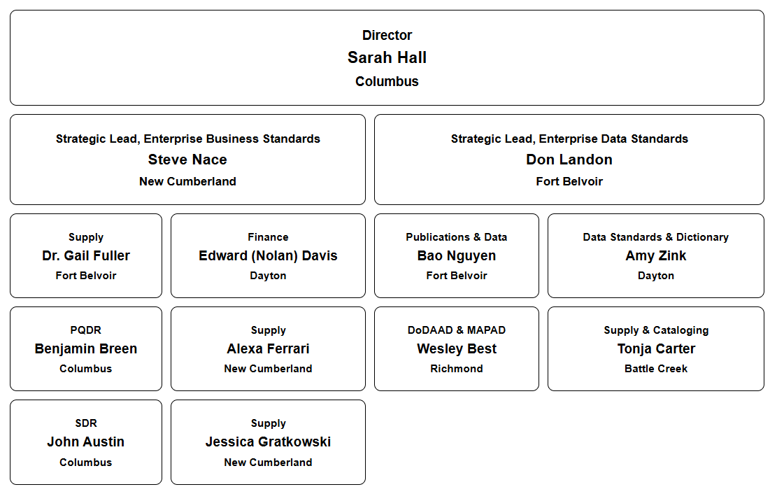

- Annual Supply Process Review Committee Appointment Letter Updates

- DEDSO reminded the SPRC members that update appointment letters would be needed from each trading partner starting in January 2026. The reminder was also sent out via email on 12/9/2025.

- PDC/ADC Addendums and MFR Formatting

  - DEDSO Director requested feedback on whether it is easier to draw relationships between related DLMS changes if we use the addendum methodology. What makes it easier for them to know what the latest/most germane DLMS change is that they need to implement? Can we provide better or more explicit information inside the ADC to assist with making correlations, relationships, or the lineage of an IC? Do they have examples of what they prefer or what doesn’t work?

- PDC 1517, Update to DLMS 947I, Inventory Adjustment to support Government Furnished Property (Supply)

  - The purpose of PDC 1517 is to provide more granularity on Government Furnished Property (GFP) and support auditability of material, the DLMS 947I Inventory Adjustments will be modified to include additional data elements to support lineage and property record.

- PDC 1515, Product Identifier Inventory Adjustments for Government Furnished Property

  - For GFP to be able to identify what item to update, we need the 4 product IDs to be included on the DLMS 947I. Those would be the NSN, Manufacturer CAGE, Part Number, and Model Number. Also, we would like the inbound and outbound Product ID 947I message to be able to be sent in one message, instead of 2, so the old NSN, Part Number, Model number and new NSN, Part Number, and Model number need to all be included on 1 947I message.

- DLMS 867I (Issue) Transaction Set Use

- DEDSO requested the supply trading partners assist them by going back internally to determine who exactly is using the DLMS 867I transaction set, and for what purpose.
- DLA mentioned that they are currently looking at end-of-day reporting (DLMS 846I (Asset Status Inquiry and Reporting)), which is also tied to some DLA NFRs. Research so far has concluded that there are many inconsistencies and imbalance issues taking place. DLA’s preference is that the 867I be sent to all systems when the MRO is sent to a DLA storage activity. DLA’s warehousing system is using system logic based on the MRO owner details and correlating it to their owner balances, and that is the basis for DLA storage activities to send the outbound transaction. However, the transaction is not sent out to all owners and there are questions about how often the warehousing system tables listing DLMS 867I recipients are being updated.
- Army informed the group that they drop inventory (decrement the inventory record balance) based on the DLMS 945A (Materiel Release Advice) transaction versus the DLMS 867I.
- As a follow up to that, a DEDSO participant stated that adjusting balances off being informed that property has been released makes the most logical sense. Additionally, DEDSO asked DLA if a MRO owner has an inventory balance, which triggers DLMS 867I (when programmed), but if no physical property exists in that location at the time of the materiel pick, causing a DLMS 945A denial, how does DLMS 867I get corrected? Is the DLMS 846I end of day balance used to update the erroneous DLMS 867I?
- DLA informed that no 846I is sent to correct an inaccurate 867I, but for Navy/Air Force a D7_ reversal is sent.

-------------------------------------------------------------------------------------------------------------------------------------------------------

[The Below Draft PDCs Updates Were Sent Out for Informational Purposes Outside of the Meeting]

- PDC 1516, Proposed Defense Logistics Management Standards (DLMS) Change (PDC) 1516 Standardizing Receipt Cancellations (Supply)

  - This PDC addresses DLMS policy clarification, system capability, and data mapping is needed for receipt cancellations. Additionally, DLA Disposition specific requirement for receipt reversals does not function as needed in The Warehouse Management System (WMS), therefore the Disposition receipt reversal policy and codes are being removed from Defense Logistics Management Standards (DLMS) 4000.25.

- ADC 267 (Withdrawal), Withdrawal of Approved Defense Logistics Management Standards Change 267, Interim Change for DLMS 527R Receipt to Support Intra-Army direct Support/Reparable Exchange Decapitalization Transaction (Supply/MILSTRAP) (Staffed as PDC 290)

- Approved Defense Logistics Management Standards Change 267 was intended as an interim deviation from normal enterprise data standards practices pending the full implementation of Army Exchange Pricing. In September of 2025, representatives from Headquarters, Army Materiel Command, confirmed to the Defense Enterprise Data Standards Office that the coding established under ADC 267 was no longer required.

- PDC 1455, Proposed Defense Logistics Management Standards Change 1455, Removal of Passive Radio Frequency Identification References in Defense Logistics Management Standards Publications and Implementation Conventions

  - This change removes Passive Radio Frequency Identification Devices (pRFID) references in Defense Logistics Management Standards (DLMS) transportation publications and implementation conventions (ICs).

- PDC 1520, Additional Property/Service ID Pair within the 945A Materiel Release Advice (Supply) New (F-35) Meet with Data team to discuss new qualifiers

  - To support the request from the Joint Strike Fighter Program that the GFP Module consumes the 945A instead of the 856S to document a shipment event of GFP to or from a contractor, the 945A needs to include Product ID data elements of NSN, Manufacture CAGE, Part Number, Model Number, and Item Name concurrently. Currently, it does not appear that all five of those data elements can be carried.

- PDC 1484A, Proposed Defense Logistics Management Standards (DLMS) Change (PDC) 1484A, Update the Defense Logistics Management Standard 888N, Cataloging New Item Implementation Convention (Cataloging/Supply)

- Due to changing requirements, the Type of Change Code (TOCC) initially being removed during the PDC, has been added back into the DLMS 888N in PDC 1484A.

- PDC 1485A, Proposed Defense Logistics Management Standards (DLMS) Change (PDC) 1485A, Update the Defense Logistics Management Standard 888M, Cataloging Item Maintenance (Cataloging/Supply)

  - Due to changing requirements, the Type of Change Code (TOCC), initially being removed during the PDC, are now included in the DLMS 888M.

- PDC 1487A, Proposed Defense Logistics Management Standards (DLMS) Change (PDC) 1487A, DLMS 846M, Cataloging Demand Implementation Convention, (Cataloging/Supply)

  - Due to changing requirements, the Type of Change Code (TOCC), initially being removed during the PDC, is now included in DLMS 846M.

- PDC 1519, DLMS 814R Cataloging update to support Action/Task ID

  - The purpose of PDC 1519 is to create the Action/Task ID required on the DLMS 814R to support FLIS Modernization.

VI. ACTIVITIES AND NEWLETTER.

DEDSO monthly updates and activities for the DLMS Community can be found via the following link: https://www.dla.mil/Defense-Data-Standards/About-Us/

VII. ADDITIONAL DEDSO Supply GENERAL COMMUNICATION.
Do you have a question, hot topic, or an update related to Supply; we encourage you to send us an email at DEDSO.Supply@dla.mil.

